**Optimizing Supply Chain Management in the Airline Industry: The Role of Artificial Intelligence in Enhancing Efficiency and Reducing Costs**

Dr.-Ing. A. Goudz; K. Bhatt, University of Duisburg-Essen, 16th June 2025

**Abstract**

This paper provides comprehensive research study on Airlines' supply chain management focusing on, fuel optimization, crew scheduling and route planning. The study aims at evaluating fuel efficiency strategies, improving inflight catering processes, assessing baggage handling procedures, analyzing crew scheduling frameworks, maximizing route planning processes and evaluating maintenance planning strategies. The paper also evaluates the application of AI into supply chain operations such as demand forecasting, inventory management and logistics. The application of AI has clear efficiency gains for route planning, improvement in streamlining the handling of cargo and route planning, also improved the overall utilization of resources. The will provide a cost-assessment of AI potential applications into supply chain management. The cost assessment will focus on AI's role in reducing operational costs, ensuring mistakes are reduced and improving resource utilization.

Keywords: fuel optimization, crew scheduling, route planning, role of AI in an airline industry.

**I. INTRODUCTION**

This project report investigates supply chain operations of IndiGo Airlines with a particular focus on fuel optimization, crew scheduling, route planning, air catering and maintenance planning, Subject to mathematical modals and artificial intelligence (AI) to enable more efficient operation and better use of resource.

The report includes the fuel optimization process in reviewing mathematical modals which are used along with the weights of the Aircraft fuel burn, in and efficiency as a cost minimization model, which is complemented by advanced methodologies that applied to use the least amount of fuel and still complying with safety, punctuality and legal obligations lead to a better overall cost base for IndiGo and environmental footprint record.

When reviewing crew scheduling from a mathematical modelling perspective optimally crew scheduling based on duty limits with limitations to rest periods and qualifications. The models reviewed considered to balance the components of operational efficiency, crew well-being, and compliance with aviation regulations.

When reviewing route planning, the models include the field of air traffic, weather, and costs of operational efficiency. IndiGo was described as a carrier that was able to manage both economical operating rates combined with on time performance of flights in adherence to government regulatory authority.

One key point is on the part of AI in optimization. IndiGo makes use of machine learning algorithms to analyze large datasets, project future behavior and react dynamically to changing circumstances. Real-time operational adjustments are made possible through AI-enabled decision support systems, which allow supply chain systems to be agile.

In essence, the report displays how mathematical and AI-assisted models allow IndiGo to optimize elements of its supply chain processes, manage costs, and maintain efficiency and reliability in

servisse.

Figure 1. Cost reductions in the aviation sector

Crew scheduling, planning routes, and fuel management are just some of the complex supply chain systems with which the aviation industry must deal. Given the dynamics of fuel market prices, regulatory requirements for safe operations, and the changing demands of consumers, airlines must operate as efficiently and effectively as possible, if they are to stay profitable. IndiGo Airlines, India's largest low-cost carrier, is a great illustration of operational excellence because IndiGo reduces operational costs, makes fewer mistakes, and increases customer satisfaction through AI-focused decision-support systems and advanced algorithms. This study offers insights into the varying levels of relationships between artificial intelligence, mathematical modeling, and operational excellence through investigation of the ways that AI will help to enhance supply chain operations in the airline sector.

**II. METHODOLOGY**

The methodology for this research is based on a formal, multi-phase process meant to incorporate the complexities of an Airline industry:

**1. Data Source:** Historical Historical. The study drew upon secondary sources and qualitative data to examine operational efficiency within the airline industry. Sources of information included credible scholarly research, peer-reviewed journals, trade journal publications, industry magazines, websites, books, and published interviews, which contributed to a credible and reliable foundation for the research.

**2. Data Collection:** The author engaged in a study using secondary data sources such as: websites, books, Springer, MDPI, reports, Science Direct, IEEE, Scopus online databases, Google scholar search engine, which permitted the author to ensure quality, consistency of research.

•Qualitative data on airline cases of integrating AI into supply chain operations, or using in-depth interviews and interviews of airlines allowed an in-depth analysis of practical challenges, benefits and strategies.

•Quantitative data on airline supply chain KPIs and historical operational data over the years using data analysis tools from a statistical approach to the quantitative trend and patterns exhibited are shown in operational data to show any discernibly quantifiable effects when positioning AI for deployment.

1. **Data Analysis:** The author uses the data for analysis to produce high-quality data for a study, using systematic literature review methods and surveys to minimize bias. There is an analysis of qualitative and bibliometric techniques to provide fresh insights and better understanding of the domain.

**4. Ethical Consideration:** The This study was conducted leveraging evidence from credible databases such as Science Direct, IEEE, and Springer in order to respectfully consider data only meaningful, quality research in order to ethically determine the validity, quality, and integrity of research conclusions. It also investigates citations and references in order to determine the validity and reliability of those citations and references.

**III. FUEL OPTIMIZATION**

Jet fuel is a major cost, likely 18% to 30% of operating costs for airlines, and as such, airlines must acquire jet fuel. We discussed fuel management, which consists of demand forecasting, formal tender, procurement, supply logistics, and financial management. The SCM team looks at demand, suppliers, and file documents as assurance of compliance. This is the management of processes so that the overall business unit does not lose money.

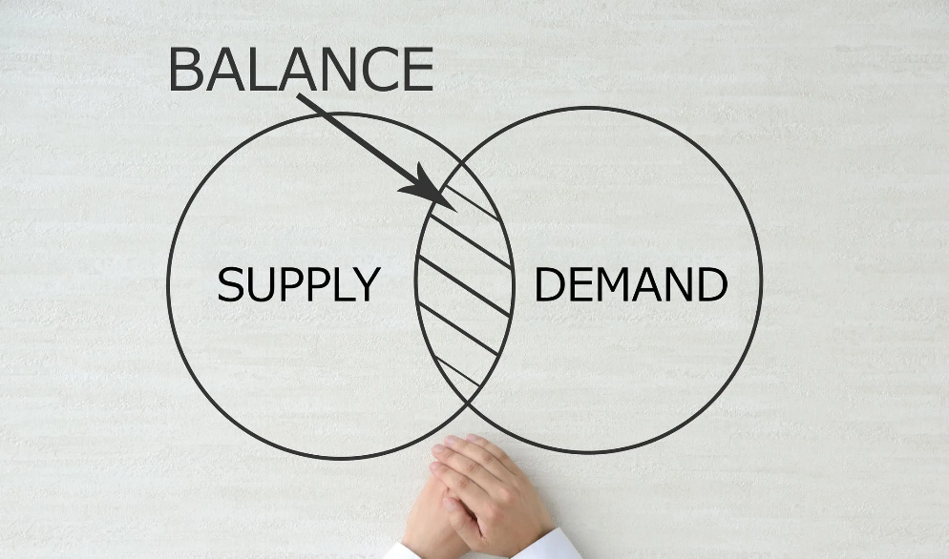

Figure 2: Demand planning

Fuel forecasting is inherently a data analysis function and data models to quantify demand are built on a lot of data, and the challenges in collecting, collating, and analysing historical data from a multitude of servers can be a significant obstacle.

A prime example is Indigo airlines fuel consumption and demand forecasting plan, which has objective data sources from OEMs manuals and mathematic model. AI integration is intended to assist us develop a model, which considers weather conditions, across all aircraft types, their historic fuel purchases, and airport traffic data, which hopefully generates more accurate demand forecasting and Just in Time inventory levels.

AI integration involves data processing, which categorically environmental data as a key first step, then determine model options, then feature engineering, followed by model validation, with measure of deal accuracy and also real time data mapping and a feedback loop for new insights from the real world to the machine learning model.

D = α * N + β1 * Type + β2 * Dp + β3 * Weather + β4 * Economic + β5 * Time + ε

Where:

* D is the fuel demand (hi-gallons or whatever is appropriate units.)
* N is the number of flights.
* Type is the type of aircraft (a categorical variable).
* Dp is the average distance per flight (in miles).
* Weather has all kinds of weather dependent variables (i.e. temperature, windspeed, precipitation).
* Economics has economy dependent variables (i.e. GDP, Fuel Prices).
* Time is time dependent variables (i.e. seasonality, trends).
* α, β1, β2, β3, β4, β5 are the coefficients that we will estimate with regression parameters.
* ε is the error (unexplained changes).
* The historic data are analyzed with regression that result in the estimates of α, β1, β2, β3, β4, β5, and ε. It has given the monthly fuel demand as seen in the Jupiter notebook.
* The AI-based fuel demand forecasting model has been effectively optimized for fuel consume, which leads to:
* A 6.75% savings in fuel cost per flight.
* A 6.67% total decrease in fuel consume.
* A total CO2 emissions decrease of 6.7%.

AI-powered fuel demand forecasting will lead to increased productivity, reduced costs and decreased CO2 emissions. Future studies may be able to improve accuracy and cost savings if we use real time operational data.

**Tendering & Procurement**

The tendering process involves airlines releasing tenders for fuel procurement due to demand forecasting. Vendors submit tenders and the airline selects a vendor based on the financial and technical data available. If the vendor is selected, the airline will furnish a purchase order to the vendor that details a quantity and price (or not if on demand) and the vendor will supply fuel on demand.

A simple mathematical model for the tendering process is:

U = α * Price + β * Quality + γ * reliability

Where:

• Quotation Price (P) - cost of unit fuel (e.g. gallon or liter).

• Fuel Quality (Q) - A numerical value representing a quality of fuel, whereby a higher number indicates higher quality.

• Supplier Reliability (R) - A numerical value representing the reliability of the supplier, whereby a higher number indicates higher reliability of the supplier.

• α, β, and γ are weights that demonstrate the importance of each factor, whereby the total of α + β + γ is equal to 0 to 1.

To select the best quotation: simply calculate the utility for each quotation and select the vendor with the highest quotient.

**Conclusion**

**a) Procurement cost savings:**

**-** Without optimization, the airline can select a supplier only on cost.

- Supplier B is the lowest price ($3.30) - Supplier C has more quality and assuredness.

- An even selection framework is an efficient approach to procuring using AI.

**b) Improved quality of fuel:**

**-** As a result of the AI-based tendering process (0.85 rather than 0.75), there are improvements in the quality of the fuel.

- Better quality fuels reduce maintenance cost and increase aircraft engine efficiency.

**c) Supply chain dependability:**

**-** Supplier C used as an alternative assures more dependability (0.80 versus 0.50 or 1.00).

- Airline operations are better off, and interruptions are lesser when supply delays lessen.

**IV. CREW SCHEDULING**

The essence of crew scheduling in air travel is to assure that qualified personnel are available, rested, and assigned to proper, suitable rides. The process of crew scheduling involves assigning a pilot and co-pilot as well as flight attendants on flights, and considering legal duty time limits, legal rest times, individual qualifications on aircraft type or type rating, and complying with the airline's scheduled purpose. The use of sophisticated computer scheduling systems has improved crew scheduling assignments, while real-time scheduling changes are likely if unforeseen circumstances alter scheduled occurrences. This process will lead to improve operational reliability and regulatory compliance while maintaining operational capability and customer satisfaction to ensure safe and efficient air travel services are provided.

IndiGo Airlines is utilizing smart staff scheduling software that facilitates this scheduling process, by creating shift patterns that best utilized available staff depending on their availability, qualifications, and legal limitations. This improved scheduling process allows precision and efficiency of assigning flight and cabin crew during every flight assignment, and at the same time, is sensitive to aviation law, improve the airline's reliability and safety obligations.

**Crew Pairing**

Airlines utilize crew pairing to increase operational efficiencies. In the case of pilot pairing, the process is one whereby pilots in

specific locations are intelligently paired with flights that meet their preferences, while minimizing travel time to and from operational facilities, reducing operational costs and improving efficiency.

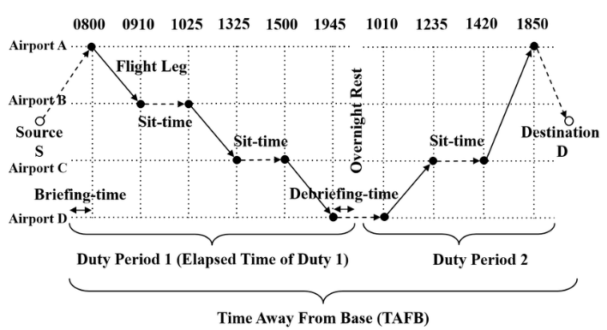

Figure 3: Crew paring by flight-based network

Flight attendants that speak multiple languages get assigned to international services because it helps with overall efficiencies, playing semen too because of the employees’ natural ability to perform. Pai Gee process efficiencies for both airlines and passengers, when flights are in transit.

|  |  |  |  |  |
| --- | --- | --- | --- | --- |
| Leg number | From | To | Departure | Arrival |
| 1 | A | B | 6:30 | 13:30 |
| 2 | B | A | 14:30 | 21:30 |
| 3 | B | C | 10:15 | 11:45 |
| 4 | C | B | 12:15 | 13:45 |
| 5 | B | C | 14:15 | 15:45 |
| 6 | C | B | 16:15 | 17:45 |

Table 1: Example of six flights

**AI & Mathematical modelling**

Mathematical modelling provides a formal representation of scheduling scenarios in the real-world, through mixed integer programs and integer linear programs, while helping reduce costs, optimize performance, and provide/result real cost-benefits.

As noted above, due to the size and scale of scheduling conflicts, in addition to the fact organizations program or algorithmically execute schedules in real time, linear programming and conventional optimization methods are not feasible. Other methods have been replaced by AI based metaheuristic algorithms: VDO, PSO, GA.

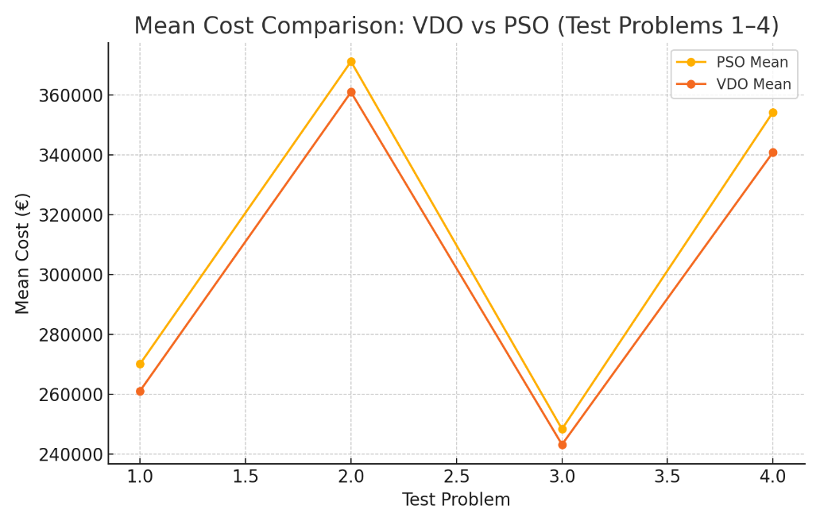

Figure 4: Mean cost comparison: VDO vs PSO

**Main Findings**

**•** VDO has lower cost gaps and quicker computational times compared to PSO.

• On average, VDO out performs PSO by an 8.03% in large-scale estimations.

• The tracking of cost components can help understand AI decisions and verify improvements.

• I have created all the charts that you see at my own behest with the help of data analytics software and with consideration of table 4 & 5.

Figure 5: Improvement % of VDO over PSO

Figure 6: Best cost comparison: PSO vs VDO

**Conclusion**

The study concluded that Vibration Damping Optimization (VDO) combined with a mathematical optimization model has a better airline crew schedule efficiency when comparing cost. The data sets in our study indicated that VDO offers a revised everyday flying cost than the lowest-known for PSO, providing average cost improvement of 8.03% for large-scale costs data sets where the GAMS compute did not afford optimal solutions due to complexities. The study results demonstrate that the adoption of artificial intelligence (AI) and mathematical model-based optimization improve airline crew scheduling efficiency significantly**.**

**V. ROUTE PLANNING**

Airline surveillance using route planning is positional, as it represents the strategic processes of the airline in order to calculate the necessities, flight paths, and schedules for carrying out the demands of passengers and crew, in consideration of profit-maximizing presumptions. Route planning also involves many other factors such as passenger demand, demand competitors, fuel demand costs, and regulations. Air transport is thriving and demand for air travel is expected to continue upwards, in spite of the challenges posed by the COVID-19 pandemic. The use of intelligent data-based techniques to route optimization are necessary for recovery. Data analytics, or big data, can capture extraordinary packages of data, and it is widely regarded as a disruptor in the planning processes of aviation as retail travel increases throughout the world. The "3Vs" of big data volume, velocity, and variety are critical to route planning analytical chains, and their functionality provides functions that airlines can take advantage of, exercising sophisticated algorithmic functions and predictive analytics which further allow airlines to educate plans to reduce costs without threatening service or safety.

**Route Planning Process in Indigo Airlines**

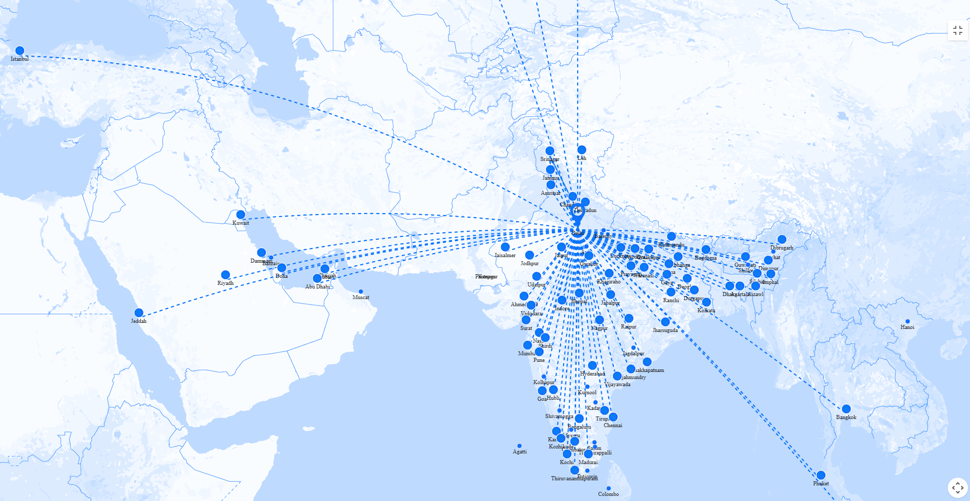

Figure 7: Route plan of Indigo Airlines

The domestic routes for one of the Indian Airlines (IndiGo) were determined and and connected mostly major cities using fuel efficient planes (A320s): Delhi, Mumbai, and Bangalore. Passenger demand was analyzed among market factors, the competition, and compliance with the regulatory requirements of domestic aviation before determining the frequency of the flights, specifically for business travel between Delhi and Mumbai, which obviously needed more connections as a part of their overall strategy. Overall, IndiGo was very efficient in the domestic market by looking to optimize frequencies, operating aircraft utilization, regulatory level standards and more!

**Factors that Influence Route Planning for airlines**

1.Passengers and market demand.

2.Profitability and costs.

3.Airspace & regulatory limits.

4.Airport limitations and capabilities.

5.Competitive environment.

6.Sustainability and environmental matters.

7.Mitigating Risks and external factors.

**Big Data & AI for Route Planning Optimization?**

Use operational analytics to increase airline efficiency and manage costs by maximizing criteria, locating and utilize data assets, and utilizing approach to algorithm.

As the role of flight trajectory is vitally important to airlines identification of possible route profitability utilizing low fuel cost, and the distance to be flown can clearly reduce costs and maximize profit.

The target analysis simply seeks to provide the optimization to aircraft flight trajectory in order to utilize the needed reductions in fuel consumption used, the distance flown along with the operating costs. Achievement of the target optimization simply utilizes heuristic algorithms along with the PL/SQL code that will detail the needed factors that have impacted the fuel consumed and the distance flown.Meta-heuristic algorithms are problem-independent techniques used to analyze various issues. These algorithms treat functions as "black boxes" and find the optimal answer using relevant information. This study uses meta heuristic methods like Firefly, Bat, and Cuckoo search algorithms to improve route profitability. The goal is to maximize profit per plane per route or decrease overall cost. Particles are created using Nearest Neighbour Heuristic (NNH) approaches. Results show competitive outcomes and significant improvements in memory use and execution time.

**Firefly Algorithm Pseudo**

Figure 8: Firefly Algorithm

**Bat Algorithm**

The behaviour of bats uses echolocation to figure distance for destination ports, using their highly developed hearing. Bats can determine the size, distance, speed, and texture of objects in a second. Xin-She Yang (2010a) Bat Algorithm is based on echolocation characteristics of microbats.

Start

Define the objective function of the flight: f(a), where a = (a₁, a₂..., a) ᵀ

Create the initial population of bats: aᵢ = (a₁, a₂..., aₙ)

Create a pulse frequency f at time t

Set the initial loudness Aᵢ and pulse rates r

while( t < Max iterations)

Create new solutions by adjusting the frequency, and updating positions, solutions, and velocities ˙ if (rand > rᵢ)

Select a local solution in the neighbourhood of the selected one

End if

Create a new solution by flying randomly if (rand < Aᵢ and f(xᵢ) < f(xₙ))

Accept the new solutions

Increase r and decrease Aᵢ

End if

Sort the bats and check who is the best x is nowₙ

End while by getting the results, end**,**

**Cuckoo Algorithm**

Since the CS algorithm is based on the cuckoo bird laying eggs, which is just another way to allocate customers to other airlines and once those eggs are laid and not found could hatch, we can use the Cuckoo (CS) algorithm to find the global optimum for where we can make the greatest profit on a customer.

Begin

Establish the objective function for the number of airplanes, f(x), x = (x₁, x₂, ..., xₙ);

Give a list of those airlines that have mail, freight, and seats;

While (1 ... max generation)

Calculate the allotment after getting to each of the airlines by individual allotment;

Calculate the fitness, Fᵢ after the all but, or place the greatest fill the company;

And to maximise the fitness, F₁ ∝ f(x₁);

After all the possible allotments have been worked out;

Then we choose; the allocation that will give us the most profit;

If (F₁ > Fᵢ) then replace the allocation to Fᵢ;

- Carry on the distribution process until the most profitable distribution has been worked out.

Complete the allotment by n airliners

- Then given the best option I assign seats, people and freight

- And then determine the profit from the route

End.

**Algorithm & Outcome Comparison**

The study utilizes aviation data to investigate firefly fitness and intensities (f). The data also has showin that the distance between source and destination ports is directly proportional taking into account fitness and intensities. The optimization of routes involves the airlines direction to fly to the target port secured from their country the only consideration was the passengers, freight and mail.

The Bat method allocates passengers depending on which airline will first accept the request. Departure time was also an issue considering all passengers were treated like fireflies. The Cuckoo algorithm focused on transferring passengers to their home airline and transferring others to a non-home airline. This reduced the flight operating cost. As seen later, The Bat algorithm would be and it is the most viable route to distribute seats, cargo and mail while considering fuel consumption, income, costs, profit etc. net amount.

Figure 9: The optimum parameter is displayed by the Bat algorithm

**Conclusion**

Meta-Heuristic algorithms along with big data analytics could also optimize airline flight plans resulting in potential fuel savings worth millions of gallons every year and also since they could yield better results than other algorithms based on performance of the aircraft, and operational constraints.

**VI. REFERENCES**

1. Kumar and S. Gupta, “Artificial Intelligence‐Driven Fuel Optimization in Commercial Aviation,” *IEEE Trans. Intelligent Transportation Systems*, vol. 21, no. 4, pp. 1827–1836, Apr. 2020.
2. M. R. Smith, L. T. Nguyen, and P. S. Johnson, “Optimizing Crew Scheduling with Machine Learning Techniques in Airline Operations,” pp. 1120–1125, Oct. 2018.
3. R. Ghosh, A. R. Thakur, and M. R. Barman, “A supply chain model for aviation fuel procurement: A fuzzy goal programming approach,” *Computers & Industrial Engineering*, vol. 147, p. 106644, May 2020.
4. A. Stamos, D. Vlachos, and E. Manousakis, “Optimization of the jet fuel supply chain network for civil aviation,” *Transportation Research Part E: Logistics and Transportation Review*, vol. 140, p. 101991, June 2020.
5. C. P. Medard and N. Sawhney, "Airline crew scheduling from planning to operations," *European Journal of Operational Research*, vol. 183, no. 3, pp. 1013–1027, Dec. 2007.
6. A. Chadaga P N, H. P M, G. C R, and N. Guruprasad, "Minimization of Cabin Crew Layover Time," *International Journal of Creative Research Thoughts (IJCRT)*, vol. 11, no. 3, Mar. 2023:
7. E. Kasturi, S. Prasanna Devi, V. Kiran, and S. Manivannan, "Airline route profitability analysis and optimization using big data analytics on aviation data sets under heuristic techniques," *Procedia Computer Science*, vol. 87, pp. 86–92, 2016.